Holston River Soil and Water Conservation District Annual Report
FY 2017-2018
Hewlett-Packard
Approved July 17, 2018

FY 2017-2018 Annual Report
Holston River Soil and Water Conservation District
448 Commerce Drive
Abingdon, VA 24211
(276) 628-8187 Extension – 4
http://holstonriverswcd.weebly.com

Mission Statement:
To promote the wise use and protection of natural resources and conservation work within the District boundaries through education, informational programs, technical assistance and the development of conservation programs addressing local conservation needs.

Vision Statement:
For Holston River Soil & Water Conservation District to become more visible as an organization dedicated to the protection of all natural resources.

For the principle concern to be the conservation and wise use of prime farmland, surface and ground water, air, forests, and urban areas through communication and cooperation with other conservation organizations, local government, land owners, schools, civic groups and businesses.

For the Board of Directors as an elected and appointed body, to keep ourselves informed of current environmental concerns and to respond to those concerns in a balanced approach to the protection of the natural resources in the area designated as Holston River Soil & Water Conservation District.

Directors:
David DeBusk, Elected
Aaron Scyphers, Elected
Henry Snodgrass, Elected
Michael Countiss, Appointed
Phil Blevins, Appointed

Associate Directors:
Dave Johnson
Martha Chapman
Adam Wilson
Tony Pane
Wayne Campbell

District Staff:
Wayne Turley, District Conservation Specialist
Mandy Fletcher, Educational Specialist
Lorie Stevens, Administrative Secretary

Natural Resources Conservation Service Staff:
Bill Moss, District Conservationist
Jason Haynes, Conservation Technician
Brandon Cole, Soil Conservationist

District Educational Programs:

The District’s educational program reached approximately 6400 educators, students, and citizens of Washington County in FY2018. Educational activities included SOL based classroom presentations, teacher trainings, field days, career fairs, public speaking events, Youth Conservation Camp, and Envirothon.

- Envirothon was one of this year’s highlights. Abingdon and Patrick Henry High Schools had Envirothon teams and Holston River SWCD hosted the county competition in March. Holston River assisted with the Area IV competition in April. Patrick Henry’s team won and represented the District at the Area IV competition.
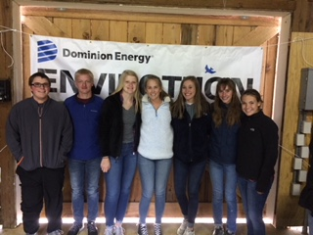
- In partnership with the City of Bristol, VA, the HRSWCD created sixty new trail signs within Sugar Hollow Park and Great Outdoors Learning Dome (GOLD). Emory and Henry College Bonner Scholars played an essential role in the creation of a new trail map, along with the installation of the trail signs.

- Our annual Sixth-Grade Farm Field Day was again held at Highland Dairy Farm. The field day was designed to enhance students’ and teachers’ knowledge of natural resource, conservation and agriculture in a hands-on “real world” environment.
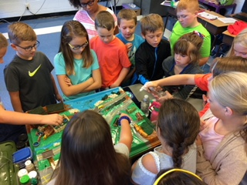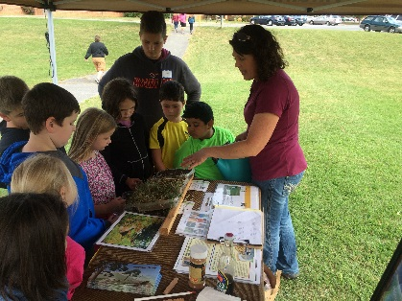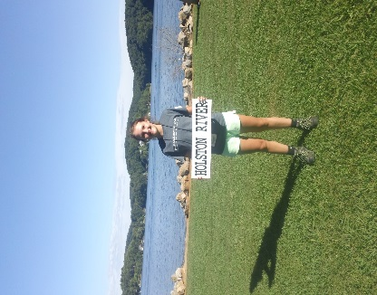

- The HRSWCD Education Specialist graduated from the Virginia Natural Resources Leadership Institute (VNRLI) with a greater knowledge of effective problem-solving, leadership skills, and additional strategies for management, protection and conservation of Virginia’s natural resources.

- A former Youth Conservation Leadership Institute participant and district volunteer was awarded a $1000 college scholarship from the VASWCD Education Foundation.

Holston River Soil and Water Conservation District
FY 2018 Cost Share Totals:

Virginia BMP Cost Share:
109 Completed Practices
2,900 of Acres Benefited
20,200 Linear Feet of Stream Exclusion
$391,529.47 in Cost Share Funds Paid Out
$20,138.04 in Tax Credits
12 Practices for Carryover
$265,373.56 in Cost Share Funds for Carryover

CREP:
9 Completed Practices
134.0 of Acres Benefited
8,300 Linear Feet of Stream Exclusion
$28,252.50 in Cost Share Funds Paid Out
$36,914.00 in Federal Funds Paid Out
10 Practices for Carryover
$11,484.62 in State Cost Share Funds for Carryover
$11,484.62 in Federal Funds for Carryover

NRCS:
54 Completed Practices
$424,902.72 in Federal Funds Paid Out

* Note: For FY2018 HRSWCD met all agreed to deliverables for Non-point Source (NPS) Implementation Assistance from the Commonwealth of Virginia Grant Agreement with the Department of Conservation and Recreation.

Awards Program:

The District’s Annual Awards Banquet was held at Highland Dairy Farm on September 19, 2017. The Following Awards were presented:

Clean Water Farm Award –
Billy Ray Dotson
Conservation Farmer of the Year –
Ann Sprinkle
Conservation Educator of the Year –
Jim McCall
Jennifer Shortt

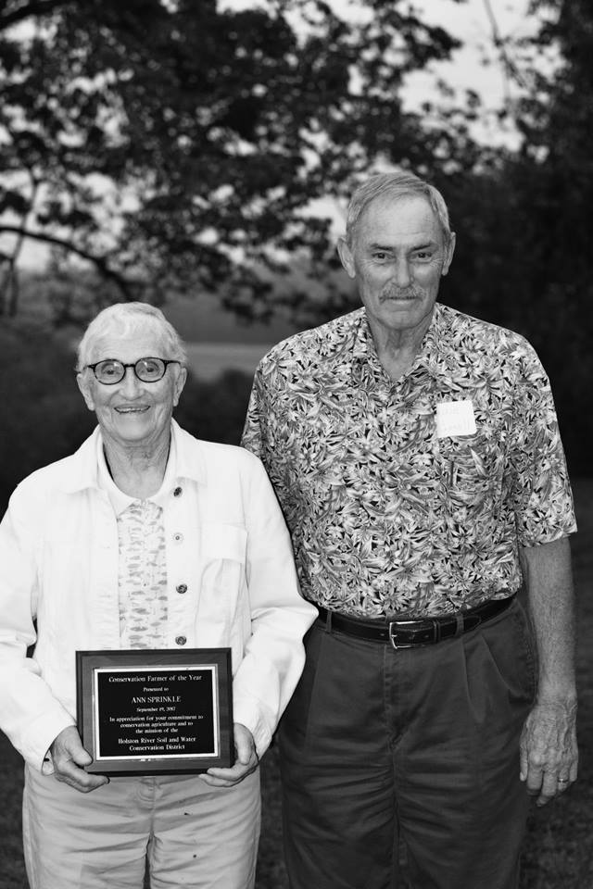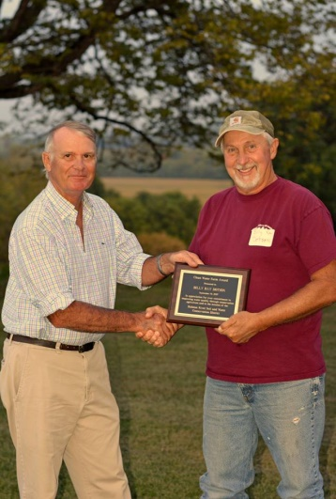

Accomplishments:

- Wayne Turley, District Conservationist, represented Area IV on the State Virginia Agriculture Best Management Practices Technical Committee for 15+ years.

- Wayne Turley, District Conservationist, serves as an advisor for the DCR Engineering Working Group.

- Mandy Fletcher, Conservation Education Specialist, supervises 4- Emory & Henry Bonner Scholars and 1 Youth Conservation Leadership Institute graduate. She is a Project WET facilitator.

- Mandy Fletcher, Conservation Education Specialist, was a graduate of the Virginia Natural Resource Leadership Institute Class of 2018.

- Lorie Stevens, Administrative Secretary, represented Area IV for the Virginia Association of Conservation District Employees for 5+ years.

- Lorie Stevens, Administrative Secretary, served as a stakeholder for the DCR Financial System Requirements Gathering Project.

